Jialin Shi

Uid 7948542502

Weka Report for problem 2-(e), (f)

**2- (e)**

**For Train:**

Train dataset: 60000, class= ‘neg’ | ‘pos’

Dataset is imbalanced.

Use Weka to train a Logical Model Tree, with cv=5 folds.

**Train Report:**

Model score

Misclassification rate = 0.00845

LMT Accuracy = 0.99155

Confusion Matrix

FP rate for ‘neg’ = 0.358 | (358 out of 1000 ‘pos’ class are misclassified as ‘neg’)

Recall for ‘pos’ = 0.642 | only 64.2% ‘pos’ are classified as ‘pos’

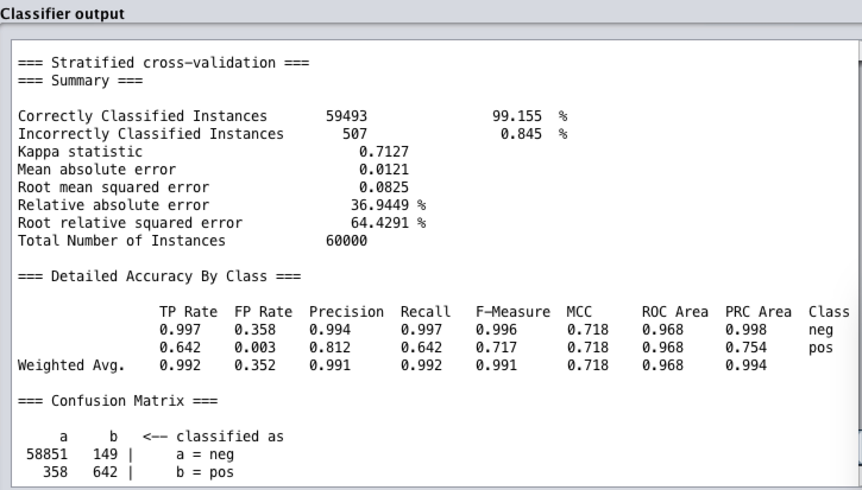

**For Test:**

Test dataset: 16000, class= ‘neg’ | ‘pos’

Reevaluate the model with test dataset.

**Test Report:**

Model score

Misclassification rate = 0.0095

LMT Accuracy = 0.9905

Confusion Matrix

FP rate for ‘neg’ = 0.291 | (109 out of 375 ‘pos’ class are misclassified as ‘neg’)

Recall for ‘pos’ = 0.709 | only 70.9% ‘pos’ are classified as ‘pos’

Auc for test = 0.9543

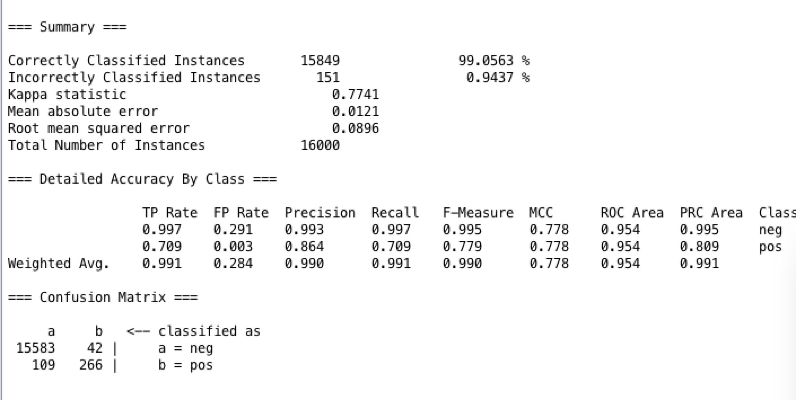

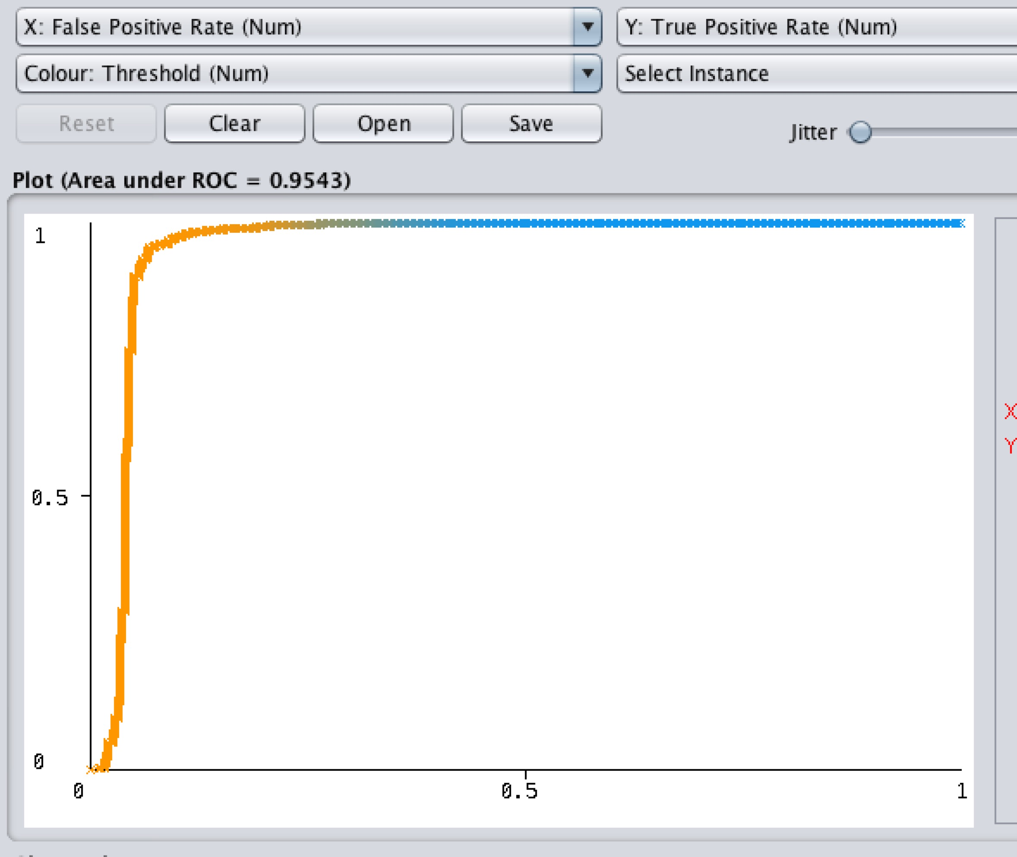

**Conclusion for 2-(e):**

Train has lower misclassification rate (I think it is because train has much bigger dataset and the data in imbalanced.)

However, train has higher FP rate for ‘neg’ class, and lower recall for ‘pos’ class.

Test Auc is lower than train Auc.

**2- (f)**

**For Train:**

Use Smote to up sample train to 120000.

Train dataset: 120000, class= ‘neg’ | ‘pos’

Dataset is now balanced.

Use Weka to train a Logical Model Tree, with cv=5 folds.

**Train Report:**

Model score

Misclassification rate = 0.0199

LMT Accuracy = 0.98

Confusion Matrix

FP rate for ‘neg’ = 0.019 | (1149 out of 59000 ‘pos’ class are misclassified as ‘neg’)

Recall for ‘pos’ = 0.981 | 98.1% ‘pos’ are classified as ‘pos’

Auc=0.995

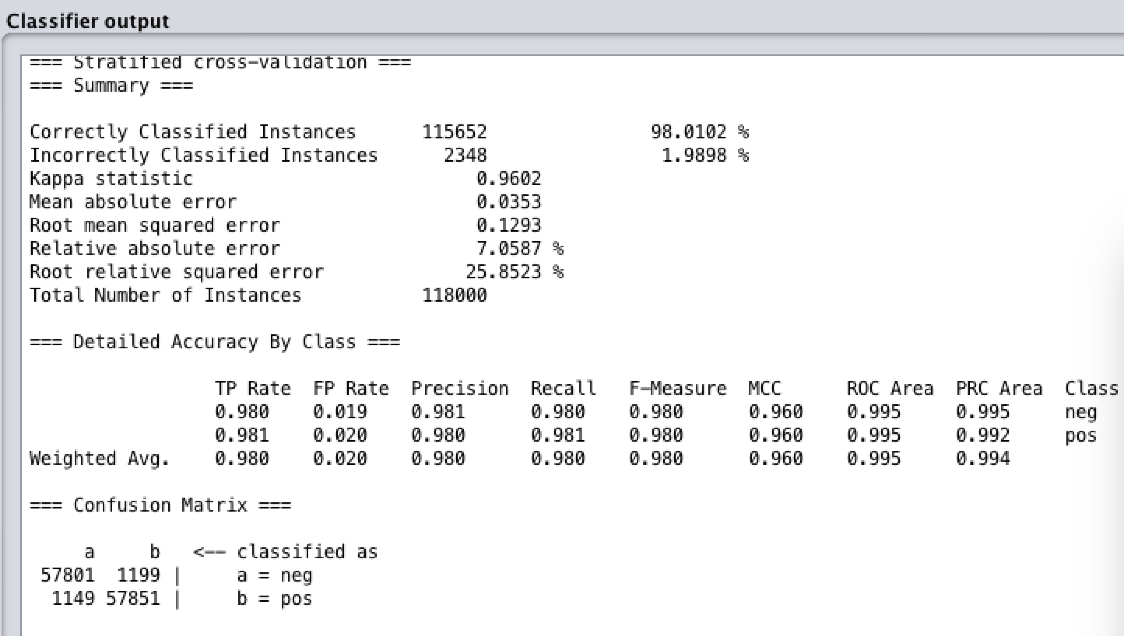

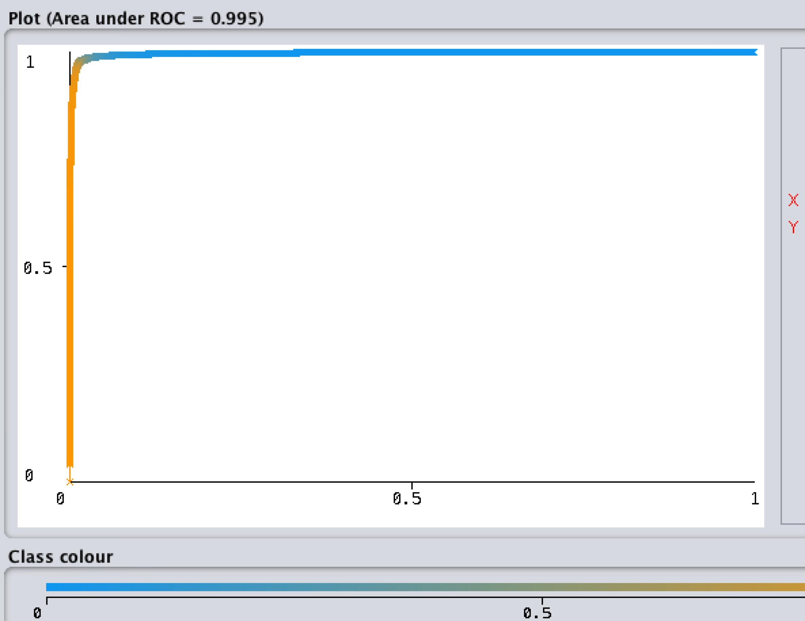

**For Test:**

Test dataset: 16000, class= ‘neg’ | ‘pos’

Reevaluate the model with test dataset.

**Test Report:**

Model score

Misclassification rate = 0.01356

LMT Accuracy = 0.9864

Confusion Matrix

FP rate for ‘neg’ = 0.176 | (66 out of 375 ‘pos’ class are misclassified as ‘neg’)

Recall for ‘pos’ = 0.824 | 82.4% ‘pos’ are classified as ‘pos’

Auc for test = 0.9207

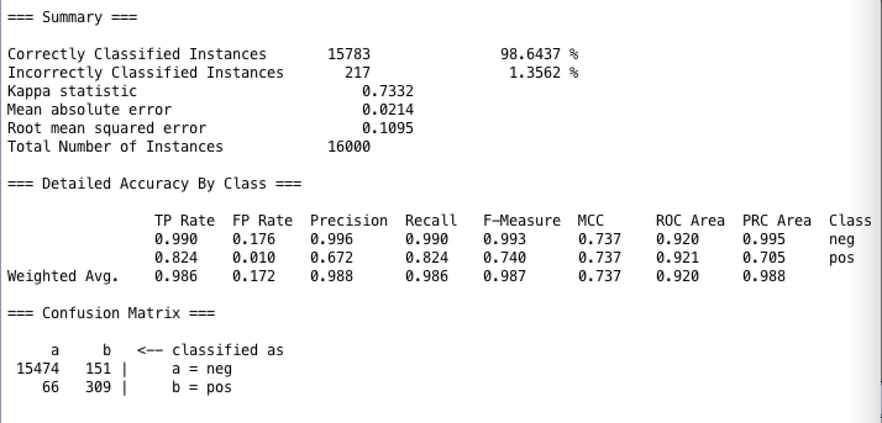

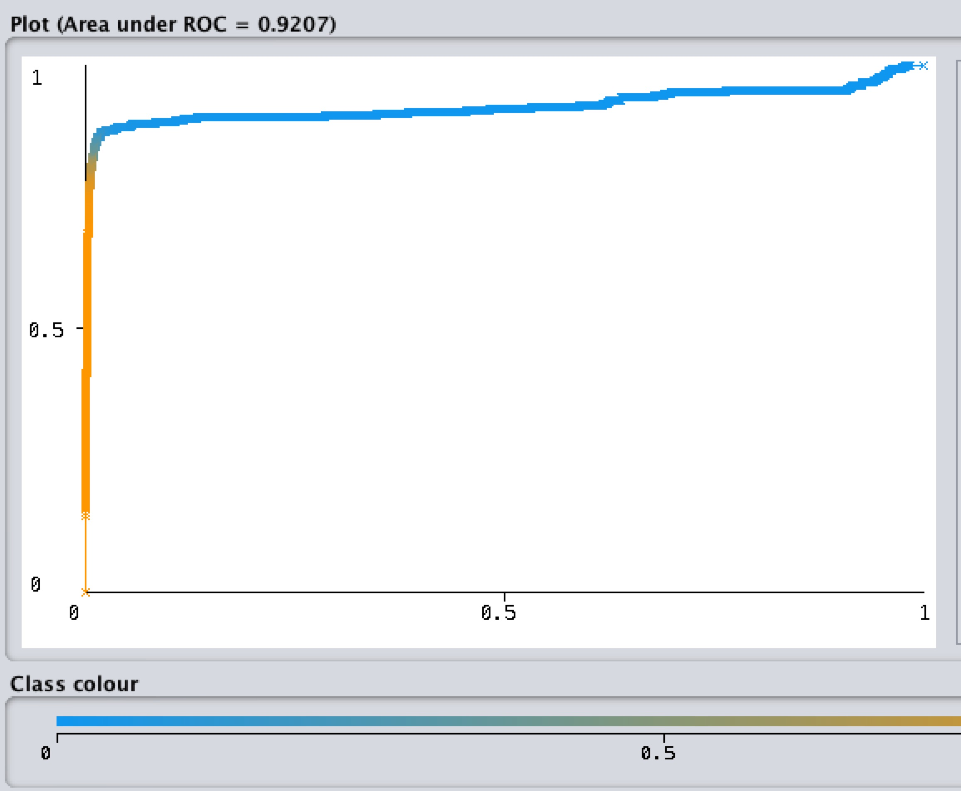

**Conclusion for 2-(f):**

Uncompensated data has lower misclassification rate and higher AUC.

However, imbalanced dataset has higher FP rate for ‘neg’ class, and lower recall for ‘pos’ class. This is because the model sees too few minor class data.

After using SMOTE to balance the data, FP rate for ‘neg’ class becomes lower and recall for ‘pos’ becomes higher, which means that the minor class ‘pos’ has been classified more accurately than imbalanced data.

Hand-written answer for ISLR

